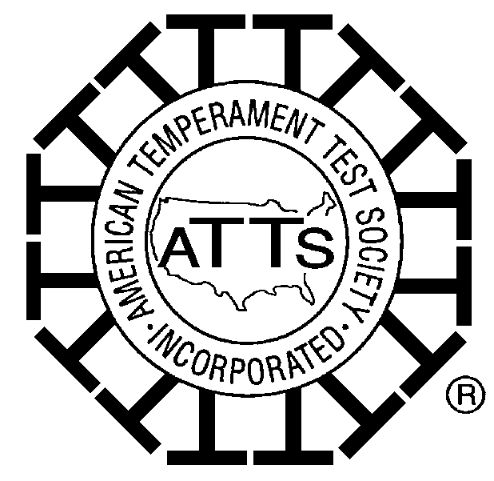
AMERICAN TEMPERAMENT TEST SOCIETY, INC. (ATTS) © 1994

PO Box 800130 ● Balch Springs, TX 75180 ● (972) 557-2887 ● www.atts.org

AMERICAN TEMPERAMENT TEST SOCIETY, INC RULES

AND REGULATIONS GOVERN THIS TEMPERAMENT TEST EVALUATION

ALL-BREED*

TEMPERAMENT TEST
(LICENSED BY THE AMERICAN TEMPERAMENT TEST SOCIETY, INC.)

HOSTED BY

American Belgian Malinois Club (ABMC)

DATE: Friday, May 10, 2013

TIME: 8:00 AM to 5:00 PM

LOCATION: Allstar Events Complex, Gettysburg, PA
2634 Emmitsburg Road, Gettysburg, Pennsylvania 17325

DIRECTIONS: Take US Route 15 to Steinwehr Avenue Exit. Travel North 2.1 miles and make a right into the Eisenhower Hotel entrance. Continue down driveway and make a slight right to Allstar Complex and proceed to parking lot past the building. Field where Temperament Test will be held is to the left of the parking lot.

PRE-ENTRIES BY: April 12, 2013

ENTRY FEE: $45.00 (U.S.) MAKE CHECKS PAYABLE TO: ABMC

($45 entry fee includes an additional $10 fee for facilities rental)

MIMIMUM AGE 18 MONTHS

SEND ENTRIES TO: Ms. Hedy Barton, P.O. Box 325, North Canton, CT 06059

Note: Entry forms and further information are available on the ATTS website: www.atts.org

*This is a Belgian Malinois Specialty and Malinois will be given preference.

DOGS PASSING THE TEMPERAMENT TEST WILL BE ISSUED A “TT”-NUMBER AND
A CERTIFICATE FROM THE AMERICAN TEMPERAMENT TEST SOCIETY, INC.

Permission for holding this event, according to the rules and regulations of the American Temperament Test Society, has been granted by the American Temperament Test Society, Inc.

